Setup the runner

* Install [GitLab Runner](https://docs.gitlab.com/runner/install/index.html) on a server separate to where GitLab is installed.

curl -L "https://packages.gitlab.com/install/repositories/runner/gitlab-runner/script.deb.sh" | sudo bash

sudo apt install gitlab-runner

Get the registration token for project:

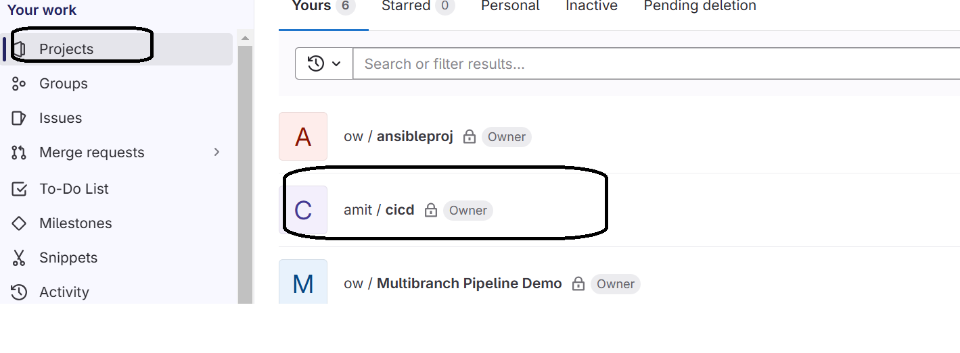

Click on Settings🡪CICD

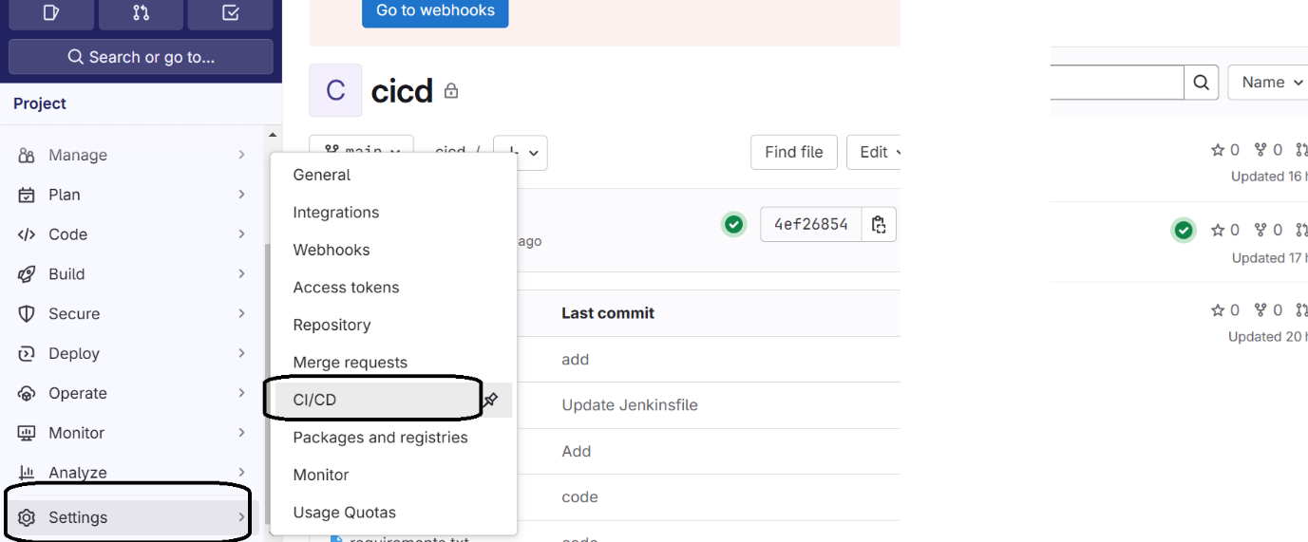

Runner🡪New Project Runner

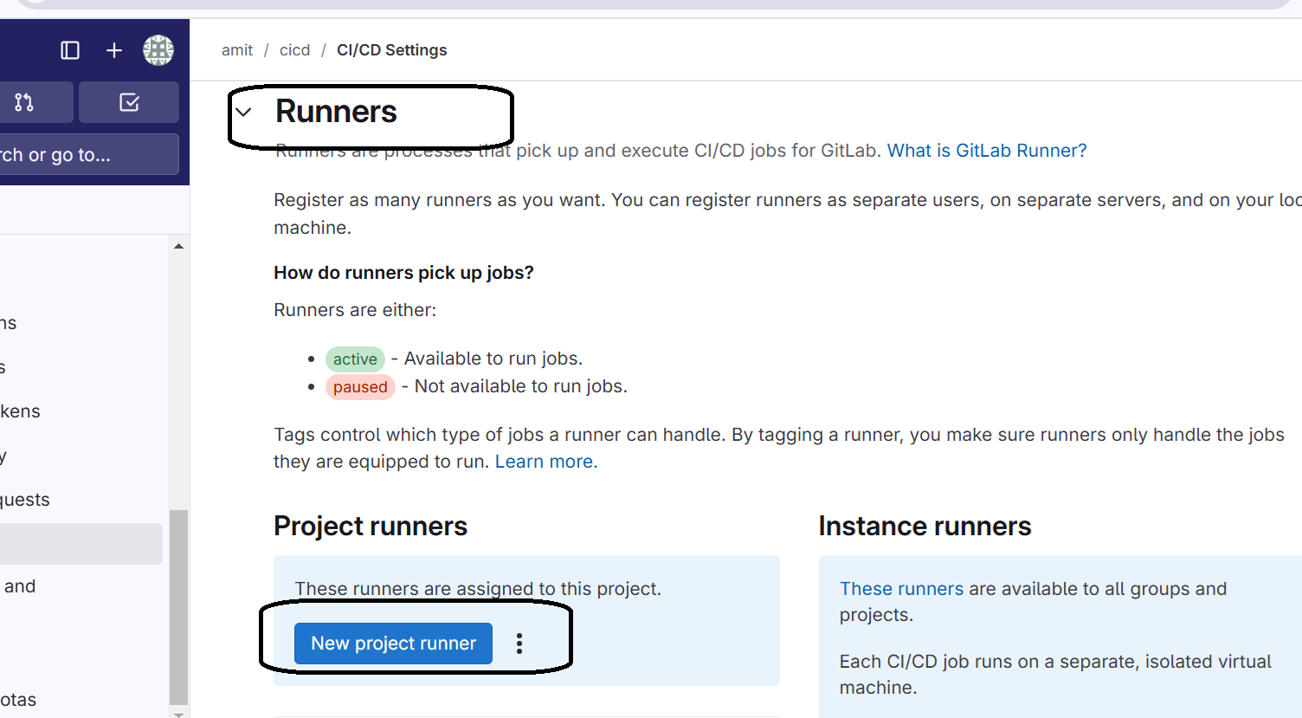

Check mark untagged jobs

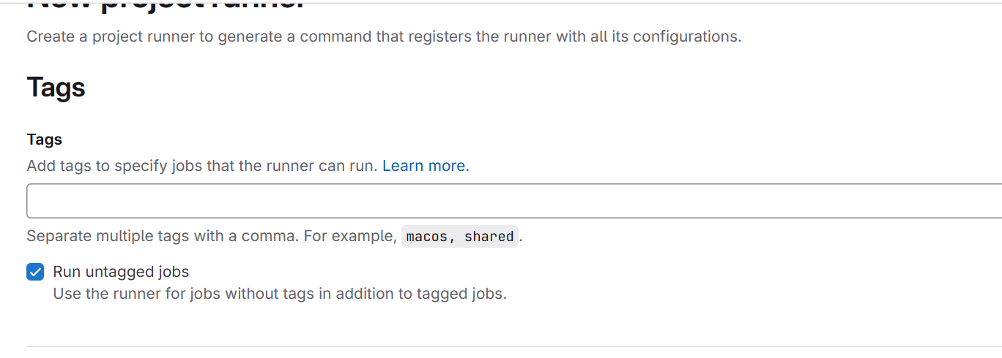

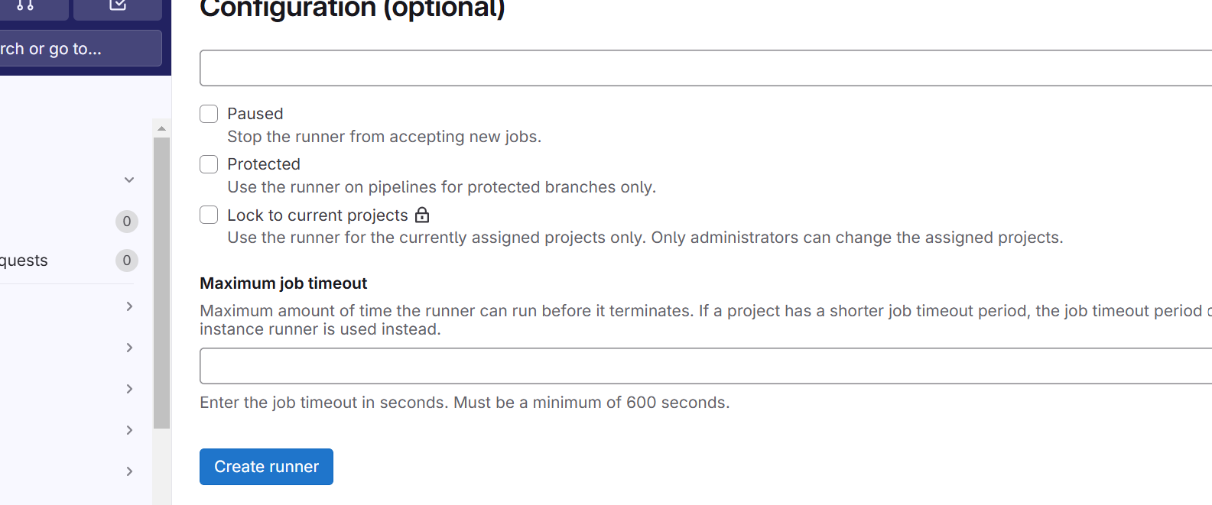

Select platform

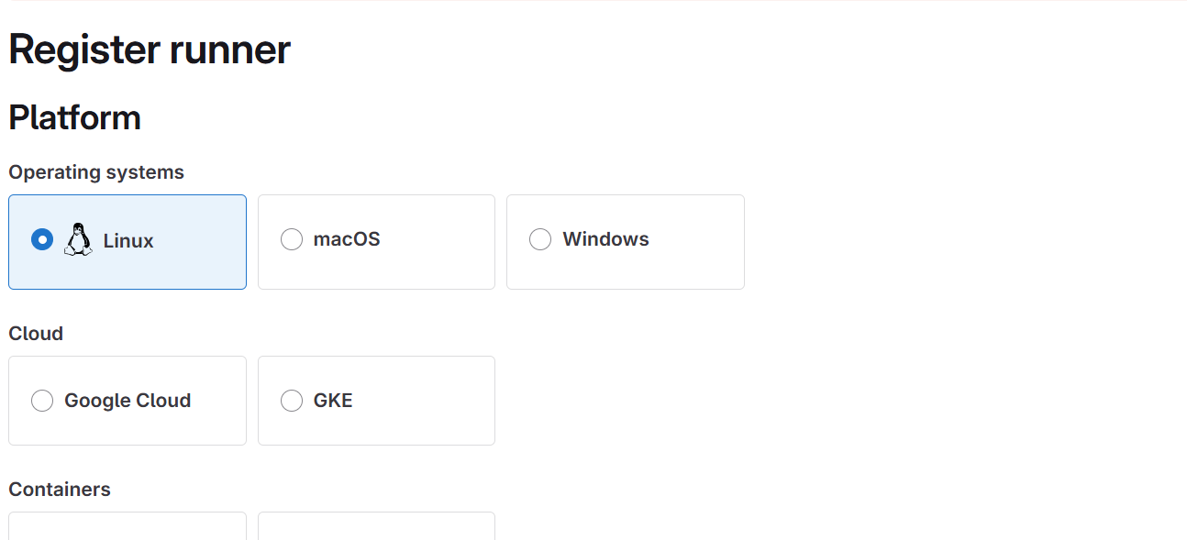

**Step 1**

Copy and paste the following command into your command line to register the runner.

gitlab-runner register --url <https://gitlab.com> --token glrt-t3_AiZKL52ha819VcRszsKj

* 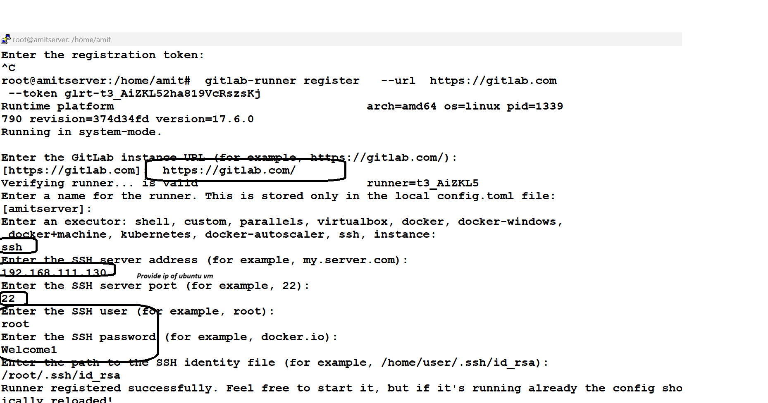

Check runner registerd

